**Name – Ayush Mondal**

**Course – B.Tech (Computer Science and Engineering 4 th sem)**

**Enrollment Number – 2011200001017**

**Registration Number – 200010170880**

1. Assignment 1

* Write a shell script to take user name as input and display it in the terminal

echo “ Enter your name : ”

read full_name

echo “Your name is $full_name”

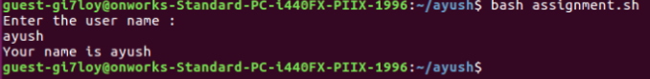

1. Assignment 2

* Write a shell script to take two numbers and show there multiplication result in terminal

echo "Enter first number : "

read first_number

echo "Enter the second number"

read second_number

result=`expr $first_number \* $second_number`

echo "The result is : $result"

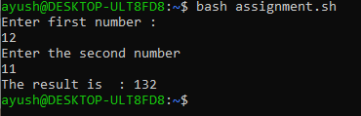

1. Assignment 3

* Write a shell script to find the average of 6 numbers

echo "Enter 6 numbers : "

read num1 num2 num3 num4 num5 num6

result=`expr $num1 + $num2 + $num3 + $num4 + $num5 + $num6`

avg=`expr $result / 6`

echo "The avarage is $avg"

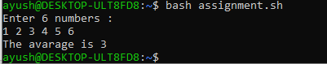

1. Assignment 4

* Write a shell script that will find the maximum from the given three numbers.

echo “ Enter three number : ”

read num1 num2 num3

if(( $num1 > $num2 && $num1 > $num3))

then

echo "$num1 is gretest number"

fi

if(($num2 > $num1 && $num2 > $num3))

then

echo "$num2 is gretest number"

fi

if(($num3 > $num1 && $num3 > $num2))

then

echo "$num3 is gretest number"

fi

